

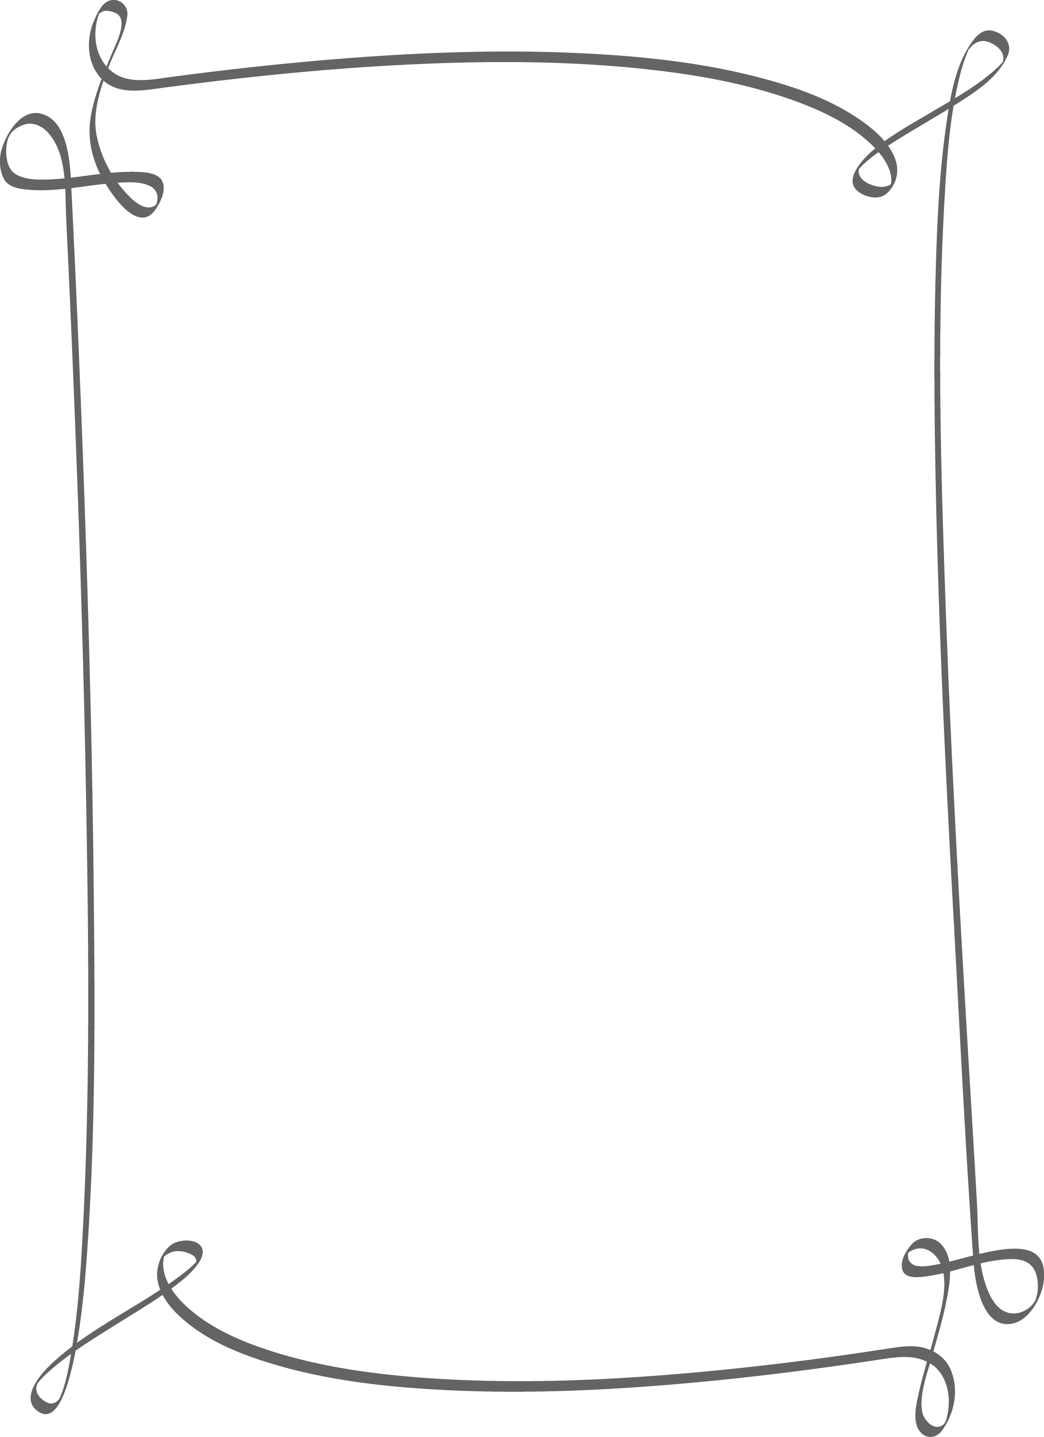

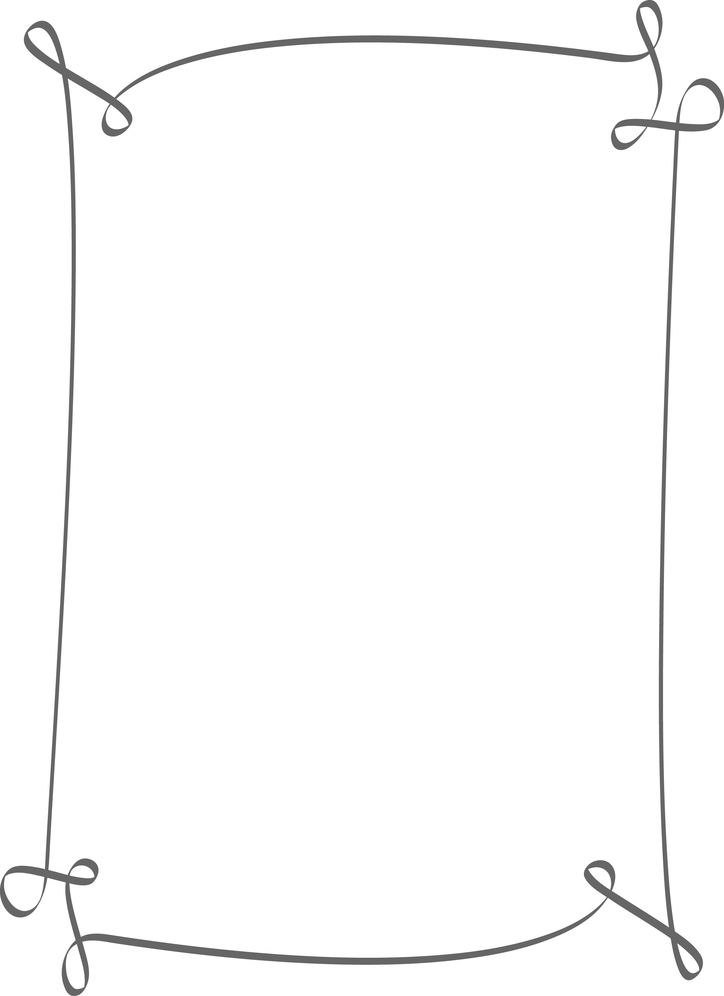

LUCERNE PUBLISHING

Cordially Invites You to Our

# ANNUAL HOLIDAY PARTY

December 13

6:00 p.m. to 9:00 p.m.

345 3rd Street, Red Suite,   
Altington, Washington

Covered parking is available.

Please R.S.V.P. by November 23 to   
Stephanie Bourne at  
someone@example.com or   
call (242) 555-0177.







